**SQS and SES Assignment**

**Problem Statement:**

**You work for XYZ Corporation. Your team is asked to deploy similar architecture**

**multiple times for testing, development, and production purposes. Implement**

**CloudFormation for the tasks assigned to you below.**

**Tasks To Be Performed:**

**1. Create a FIFO SQS queue and test by sending messages.**

**2. Register your mail in SES and send a test mail to yourself**

1. Create a FIFO SQS queue and test by sending messages:

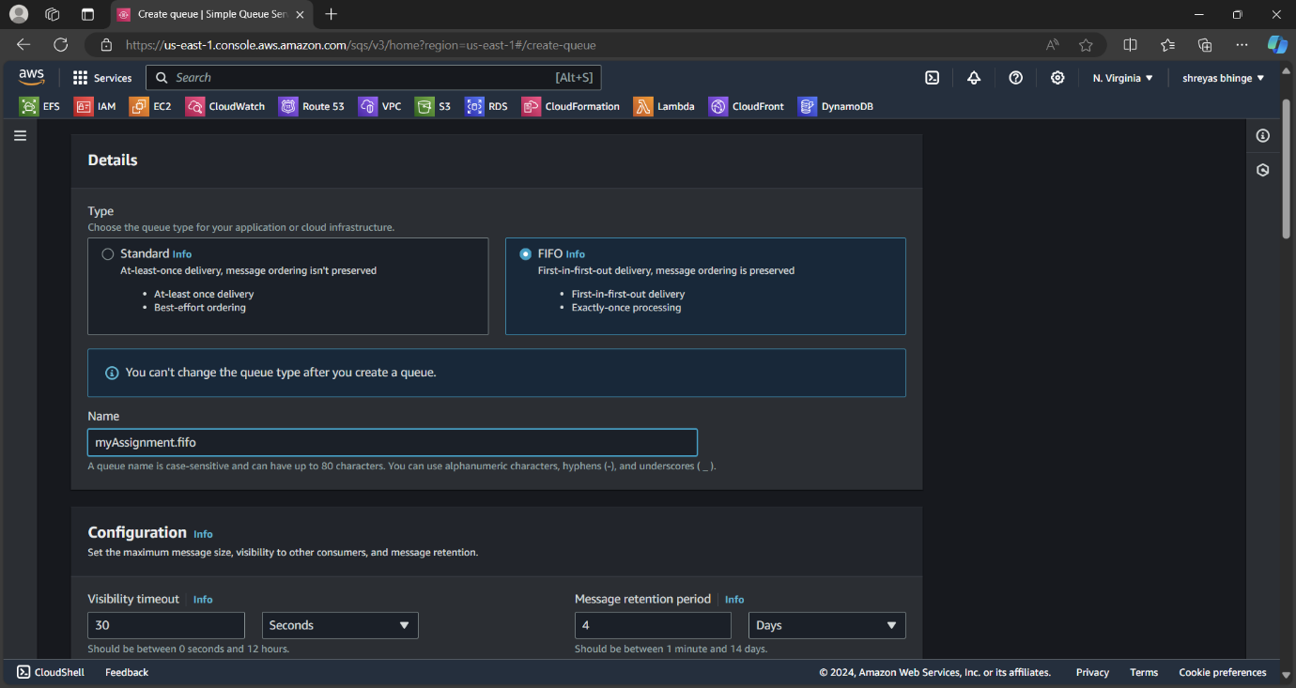

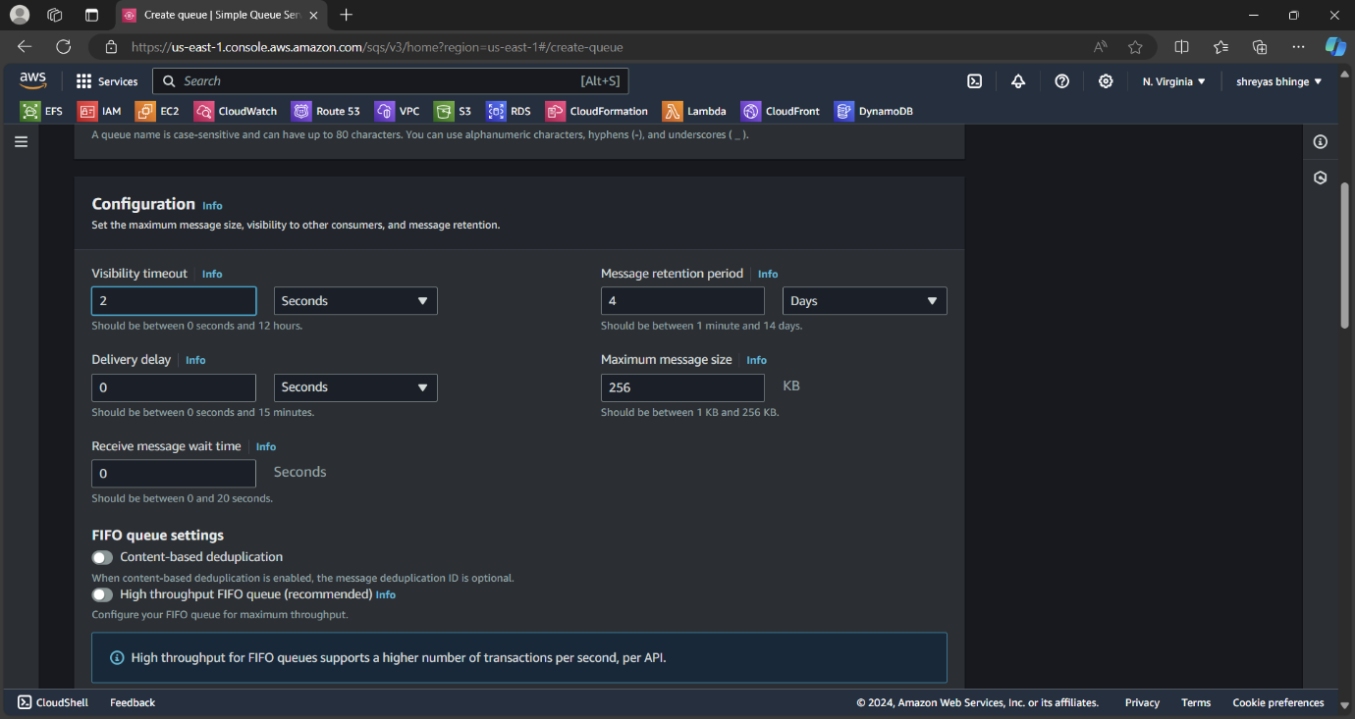

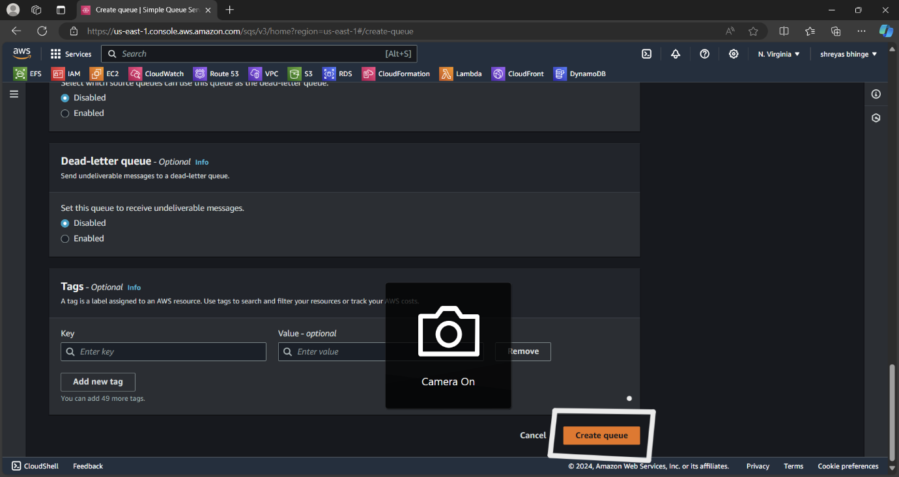

Queu will be created Then click on send and receive message

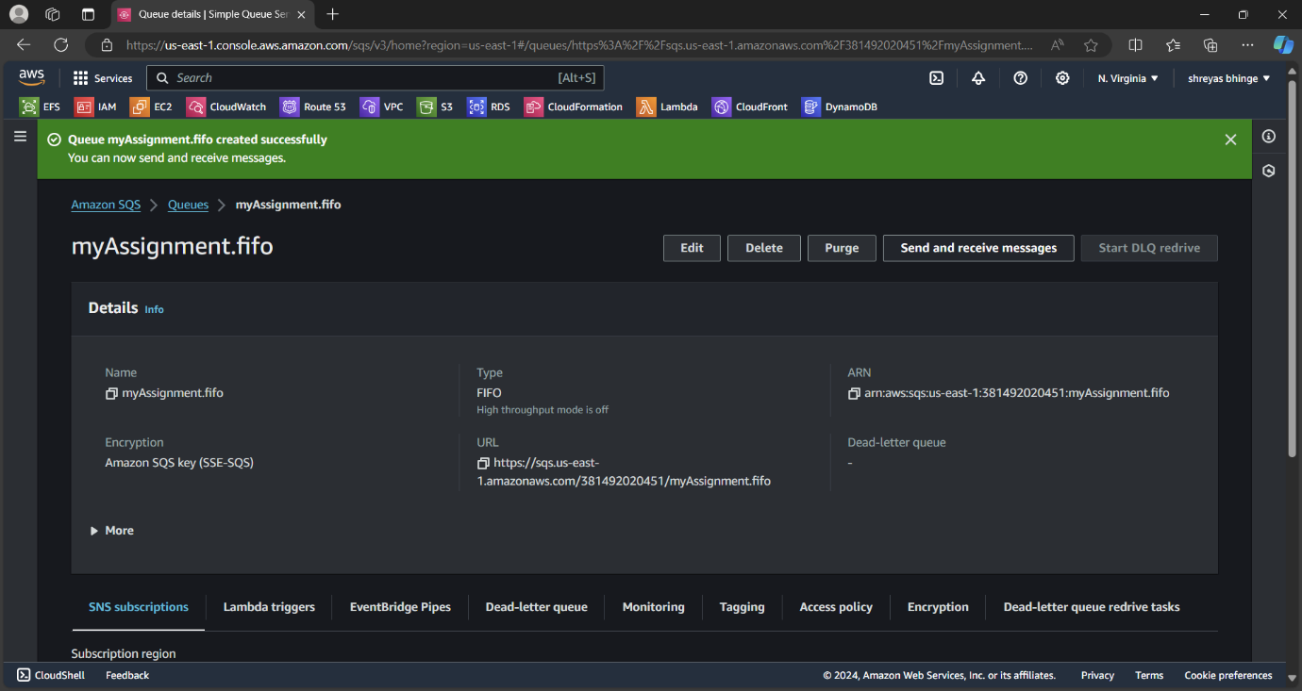

Add message body and other info

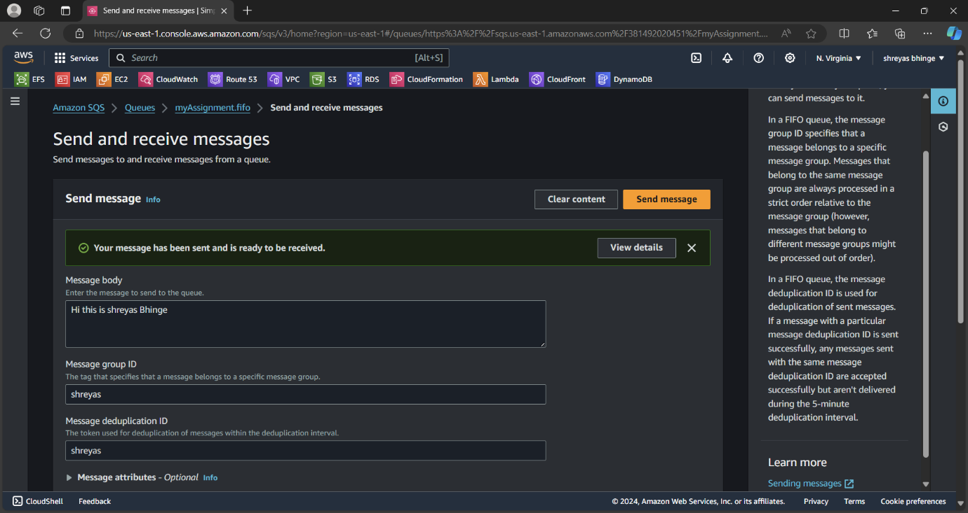



Click on poll message

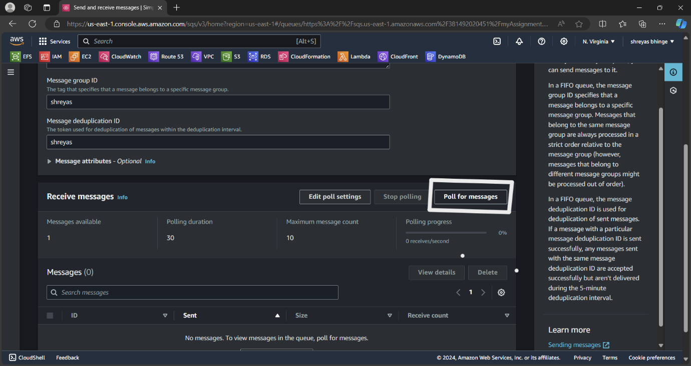

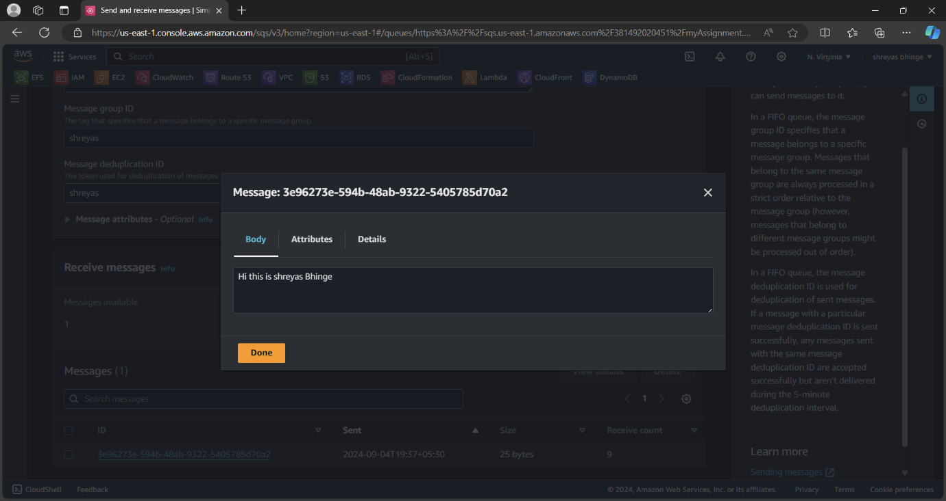

2. Register your mail in SES and send a test mail to yourself

Go to SES and create identity

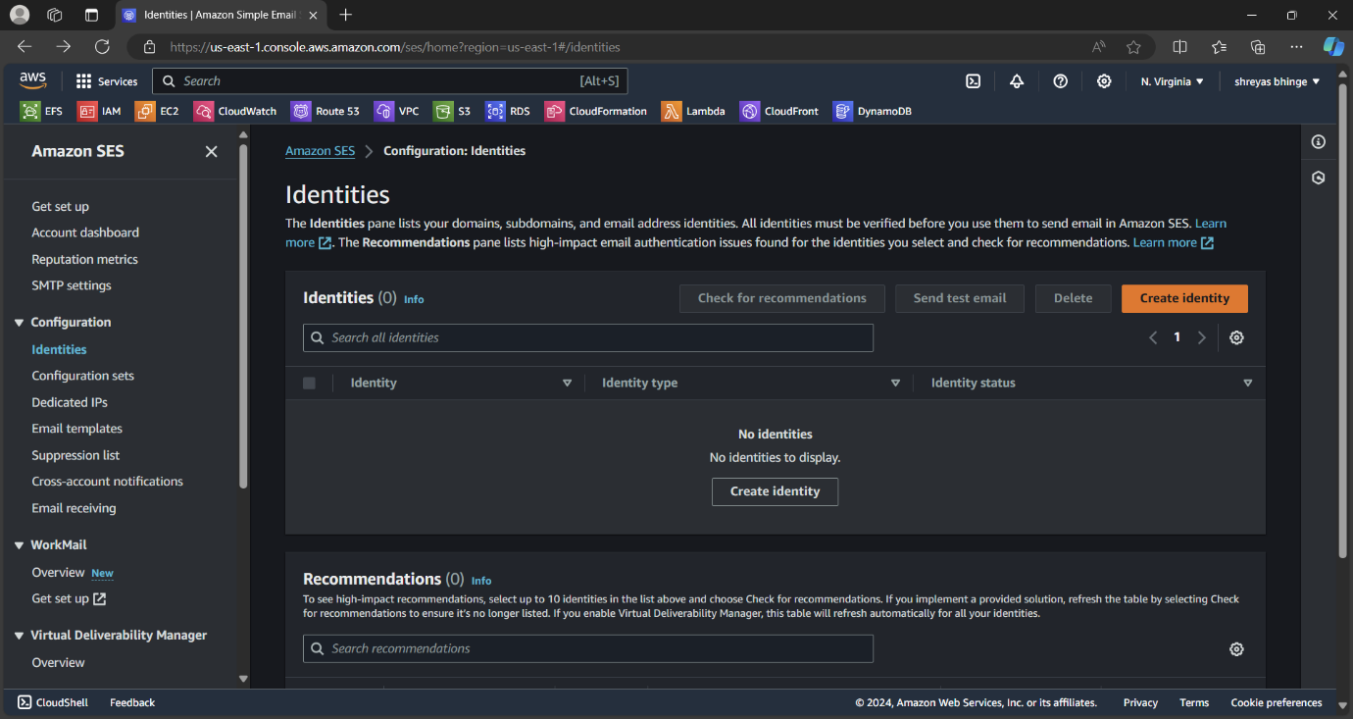

Add E-mail address

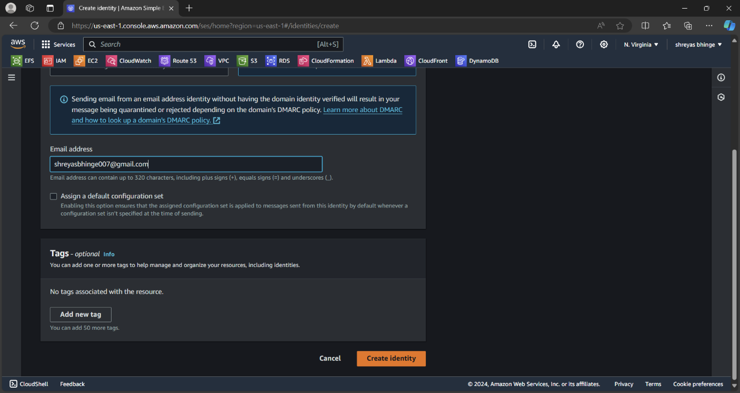

Verify E-mail in the G-mail

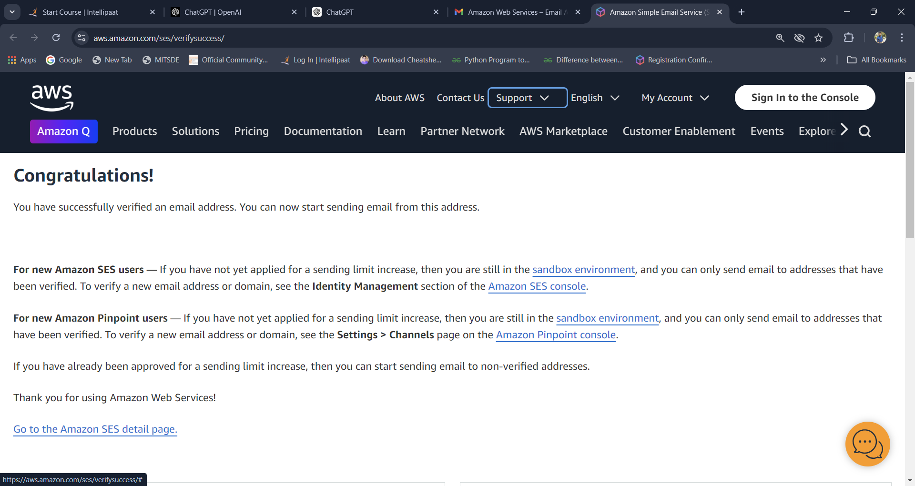

Click on send and test message

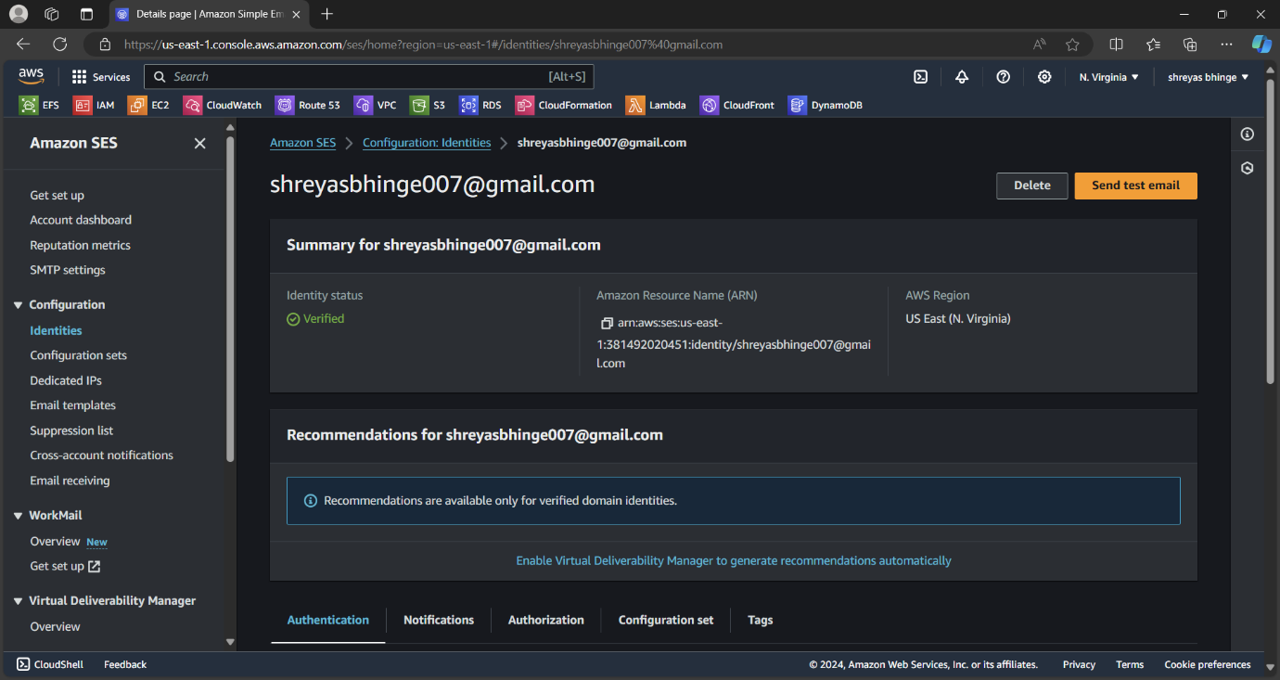

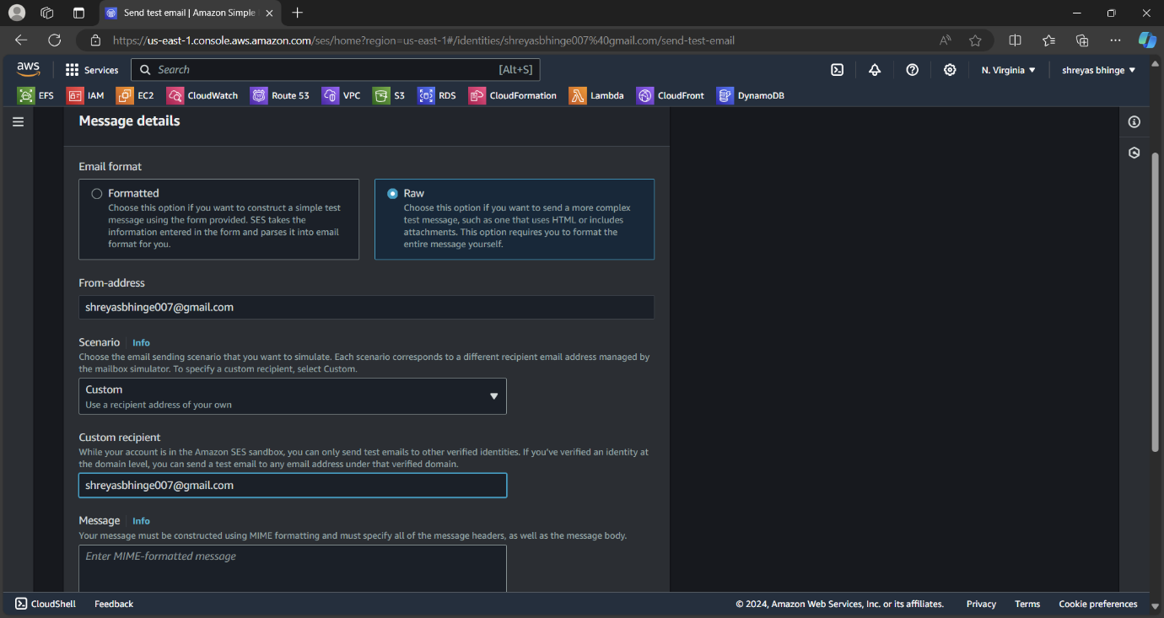

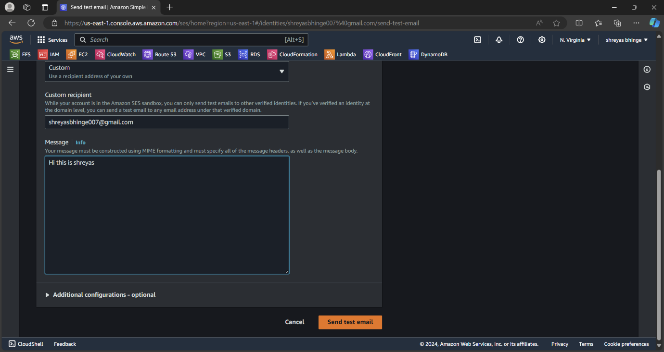

And you will receive the Mail.